# **Blog 1**

**The Role of Inland Container Depot (ICD) in Streamlining India's Supply Chain**

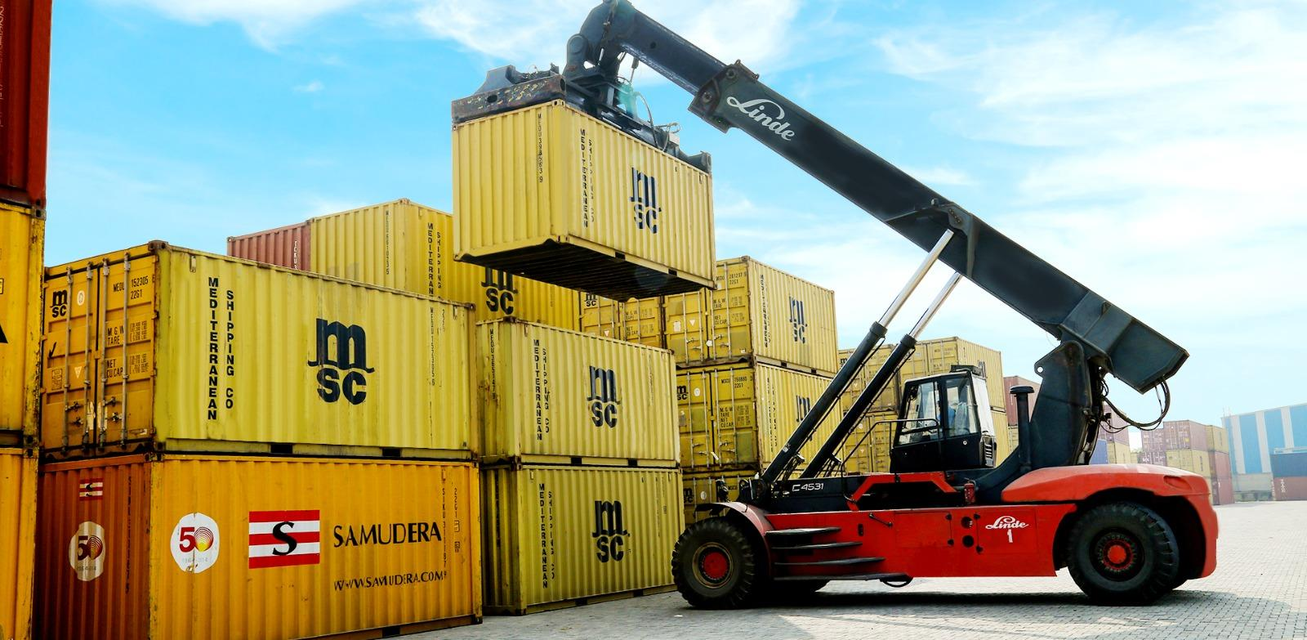

Ever wondered how an Inland Container Depot (ICD) located miles away from seaports could revolutionize a nation’s supply chain? What makes inland facilities critical to enhancing trade efficiency? If yes, then you are definitely not the only one asking how businesses can move their shipments so efficiently from areas far away from the coast. Get ready to discover the answers to how these facilities are changing the landscape of logistics.

Let's enter the game-changing solution with ICD, which is emerging as vital players in India's logistics landscape. It offers businesses a seamless way to manage goods flow across the country’s vast hinterland. These facilities act as vital hubs that enhance the movement of containers and improve the efficiency of transportation, storage and handling before they move to their final destination. It is located inland, away from seaports, making it easier to manage goods closer to consumers and businesses. It is equipped with the necessary infrastructure for container handling warehousing and customs clearance, enabling smooth operations in the supply chain.

**But what exactly is ICD and how can it transform your supply chain?**

Let’s dive deep into the world of ICD and explore its pivotal role in reshaping India's supply chain. From understanding the basics of it to uncovering its numerous benefits, we will let you know through the current state of India's supply chain and reveal how these multimodal logistics hubs are paving the way for a more efficient future. First, we will explore the key benefits, services, technological advancements, government initiatives and future prospects of India’s ICD revolution.

**Definition and purpose of Inland Container Depot**

Inland Container Depot (ICD) is a specialized facility located away from seaports that serves as crucial nodes in the supply chain network. These terminals act as intermediary points for handling, storing and transferring containerized cargo between different modes of transportation. The primary purpose of this facility is to decongest seaports, reduce transportation costs and facilitate smoother movement of containers across the country.

**Key components**

An efficient ICD comprises several essential components that work together to ensure seamless operations:

| **Component** | **Function** |
| --- | --- |
| Container yard | Storage and handling of containers |
| Customs clearance area | Inspection and documentation processing |
| Warehousing facilities | Short-term storage of consignments |
| Railway sidings | Direct rail connectivity for container movement |
| Truck parking area | Staging area for trucks awaiting loading/unloading |
| Administrative offices | Management and coordination of terminal operations |

**Differences between ICD and seaports**

While ICD and seaports share some similarities in terms of cargo handling, there are notable differences:

| **Feature** | **Inland Container Depot** | **Seaports** |
| --- | --- | --- |
| **Location** | Situated inland | Located along the coast |
| **Connectivity** | Primarily relies on road and rail connectivity | Direct access to sea routes |
| **Capacity** | Typically, smaller handling capacity | Larger handling capacities |
| **Customs Procedures** | Can perform customs clearance for import/export cargo, reducing congestion at seaports | Customs clearance primarily at the port |
| **Multimodal Integration** | Excels in integrating various transportation modes, offering more flexibility in cargo movement | Primarily focuses on sea transport with road/rail connections |

Now that we have a clear understanding of ICD, let's explore the key benefits it offers.

**Key Benefits**

* **Reduced transportation costs:** Reduce transportation costs by eliminating the need for long-distance hauls from seaports to inland locations.
* **Improved efficiency:** By consolidating cargo at ICD, businesses can streamline their logistics operations and reduce handling time.
* **Enhanced connectivity:** These facilities are well-connected to major transportation networks, including roads, railways and highways, ensuring efficient freight movement.
* **Faster delivery times:** It can significantly reduce delivery times to inland destinations, improving customer satisfaction and market competitiveness.
* **Infrastructure Development:** The establishment of ICD has led to the development of infrastructure in inland regions, boosting economic growth.

**ICD offers a wide range of services, including:**

* **Multimodal transportation:** It facilitates the seamless transfer of cargo between different modes of transportation, such as road, rail and sea.
* **TXR Examination:** Through this, it ensures safety and efficiency by inspecting train wagons for mechanical, brake and load issues.
* **Container leasing and repairing:** It provides container leasing and repairing services that ensure cost-effective, flexible and well-maintained solutions for businesses.
* **Customs clearance:** The facility often has customs clearance facilities, simplifying the process for importers and exporters.
* **Stuffing:** It can handle the stuffing of containers, reducing the workload for businesses.
* **Warehousing services:** Some ICD offer additional services like warehousing for storage of domestic and EXIM cargo.

**Government initiatives supporting development**

The Indian government has recognized the crucial role of ICD in enhancing the country's supply chain efficiency. To this end, several initiatives have been launched to support and promote its development across the nation.

**A. Government Policies**

The government has implemented various policies to encourage the establishment of ICD:

* **National Logistics Policy (NLP)**: This comprehensive policy aims to reduce logistics costs and improve efficiency, with a specific focus on promoting ICD as key infrastructure components.
* **100% FDI allowance**: The government permits 100% Foreign Direct Investment (FDI) in the logistics sector, including ICD, attracting international expertise and capital.

**B. Infrastructure development projects**

To support ICD operations, the government has initiated several infrastructure projects:

* **Dedicated Freight Corridors (DFCs)**: These high-speed rail corridors are being developed to connect major industrial centers with ports, enhancing connectivity with ICD.
* **Sagarmala Project**: This initiative focuses on port-led development, will enhance the last-mile connectivity for ICD.

**C. Public-private partnerships in ICD operations**

The government has been actively promoting Public-Private Partnerships (PPPs) to leverage private sector expertise:

* **Viability Gap Funding (VGF)**: This scheme provides financial support to PPP projects in the infrastructure sector.
* **Land lease agreements**: Government-owned land is offered on long-term lease to private operators for ICD development.

These initiatives have significantly boosted the growth of ICD across India, contributing to a more efficient and cost-effective supply chain.

**Future Prospects**

As we look ahead, the future of ICD in India appears promising, with significant potential for growth and technological advancements that will reshape the logistics landscape.

**Potential for Growth and Expansion**

* Increasing international trade volumes require more ICD
* Government initiatives to boost exports encourage expansion
* Development of dedicated freight corridors Improved connectivity enhances efficiency
* Rising demand for efficient logistics solutions

**\*\*\***

# 

# 

# **Blog 2**

**How multi-modal transportation at Sanjvik Terminals enhances logistics efficiency  
  
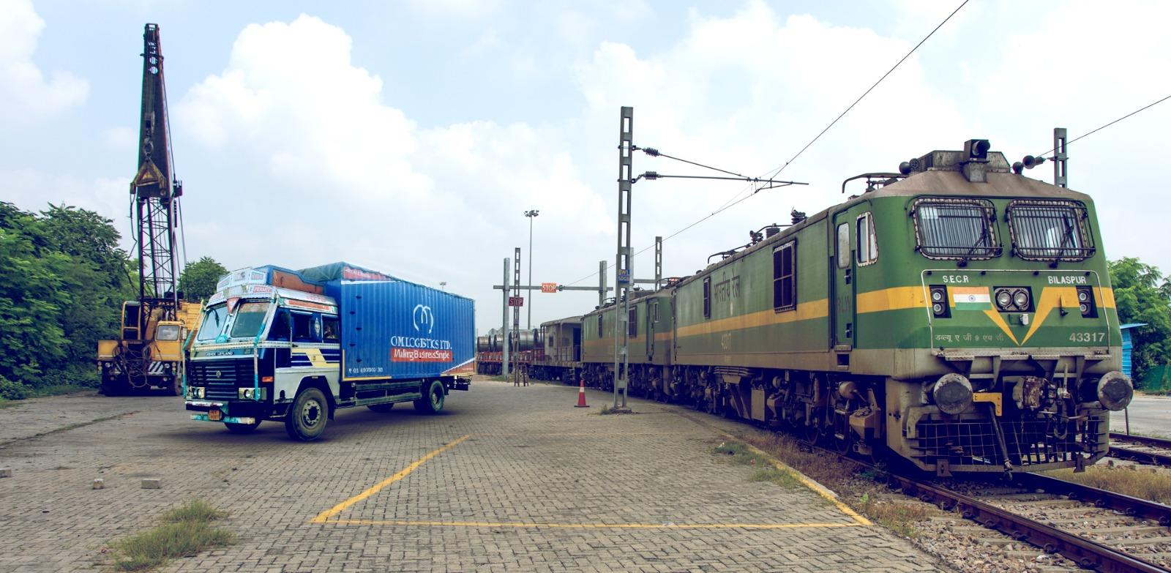**

As industries expand, the demand for more efficient and cost-effective **logistics solutions** has increased more than ever. At the heart of this evolution lies **multi-modal transportation**, a system that has revolutionized the way goods are transported. **Sanjvik Terminals Pvt. Ltd. operated Inland Container Depot (ICD) at Bawal**, strategically positioned near key industrial zones in northern India, has embraced this approach, significantly boosting **logistics efficiency**.

We will know further how **multi-modal transportation** at Sanjvik Terminals contributes to optimizing freight operations, enhances containerized cargo movement and strengthens **supply chain management** in India. Before, let's understand the term - Multi-Modal Transportation**.**

**What is multi-modal transportation?**

**Multi-modal transportation** refers to the movement of cargo using more than one mode of transport- such as road, rail, sea and air - within a single journey, all coordinated under a single contract. This integrated approach allows for smooth transitions between different modes of transportation, ensuring **efficient cargo movement** from origin to destination. By combining multiple transport methods, **multi-modal logistics** improves operational flexibility, cost-effectiveness and delivery timelines, benefiting industries of all sizes.

At **Sanjvik Terminals**, **multi-modal transportation** is at the core of its operations. With access to advanced infrastructure and seamless connectivity by road, rail, air and sea, the terminal ensures that containers are handled with precision and moved efficiently across various transit points with no delay.

**Enhancing logistics efficiency through multi-modal solutions**

The ability to move goods efficiently is key to staying competitive in a global landscape. **Sanjvik Terminals** has developed a network of transportation solutions that integrate each mode of transport, leading to enhanced **logistics efficiency**. Here’s how:

**Integrated transport solutions for seamless connectivity**

One of the biggest advantages of **multi-modal logistics in India** is the flexibility it offers in managing cargo movement. **Sanjvik Terminals** provides **integrated transport solutions** that leverage its strategic location and transportation links, ensuring swift and efficient movement of containers.

Located within the **HSIIDC industrial estate** in Bawal, Haryana, **Sanjvik Terminals** strategically situated near major highways like NH-48 and NH-71, connecting the terminal to critical industrial hubs. Close proximity to the **Delhi-Mumbai Industrial Corridor (DMIC)** and **Indira Gandhi International Airport (DEL)** further enhances air cargo handling efficiency, providing a vital link for businesses requiring rapid air freight solutions. Its seamless rail connectivity to major ports such as Mundra, Pipavav and JNPT through the **Western Dedicated Freight Corridor (WDFC)** ensures timely transport of containers. This strategic location allows for quick transit across western India, eliminating unnecessary delays that often occur in traditional transport systems.

**Optimizing freight with multi-modal logistics in India**

At **Sanjvik Terminals**, the adoption of **multi-modal transportation** ensures that the right mode of transport is used at each stage of the journey. This flexibility means that container can be shifted from one mode to another based on factors like cost, speed and distance.

For instance, while rail transport might be cost-effective for long-distance bulk shipments, road transport is often more efficient for short-distance deliveries. By integrating both modes, **Sanjvik Terminals** can offer **freight optimization**, ensuring that businesses benefit from cost savings and faster delivery times.

This model not only reduces transit time but also minimizes handling, leading to fewer damages and reducing the overall operational costs for businesses.

**The role of technology in enhancing transparency**

In addition to physical infrastructure, **Sanjvik Terminals** has invested heavily in advanced technologies to further boost **logistics efficiency**. The integration of **FOIS (Freight Operations Information System)** provides real-time tracking and transparency of cargo as it moves through different stages of its journey. This level of visibility allows businesses to better plan their operations, ensuring on-time deliveries and minimizing delays.

**Environmental and economic benefits**

One of the often-overlooked benefits of **multi-modal transportation** is its positive impact on the environment. By optimizing routes and combining different transport modes, businesses can significantly reduce their carbon footprint. Rail transport, for example, is more energy-efficient than road transport, particularly for bulk shipments over long distances.

**Unlocking efficiency**

As businesses in India and across the globe continue to expand, the demand for efficient and reliable **supply chain management** solutions is on the rise. **Sanjvik Terminals** is at the forefront of this transformation, offering **multi-modal logistics** that streamline **the movement of containers.** With its **integrated transport solutions**, the terminal not only enhances **logistics efficiency** but also offers businesses the flexibility to meet their unique transportation needs.

In a competitive market, the ability to move containers quickly and efficiently can make all the difference. We ensure that businesses across India can stay connected, responsive and ready to meet the demands of their customers.

# **Blog 3**

**How Sanjvik Terminals enhances supply chain efficiency with its reliable services**

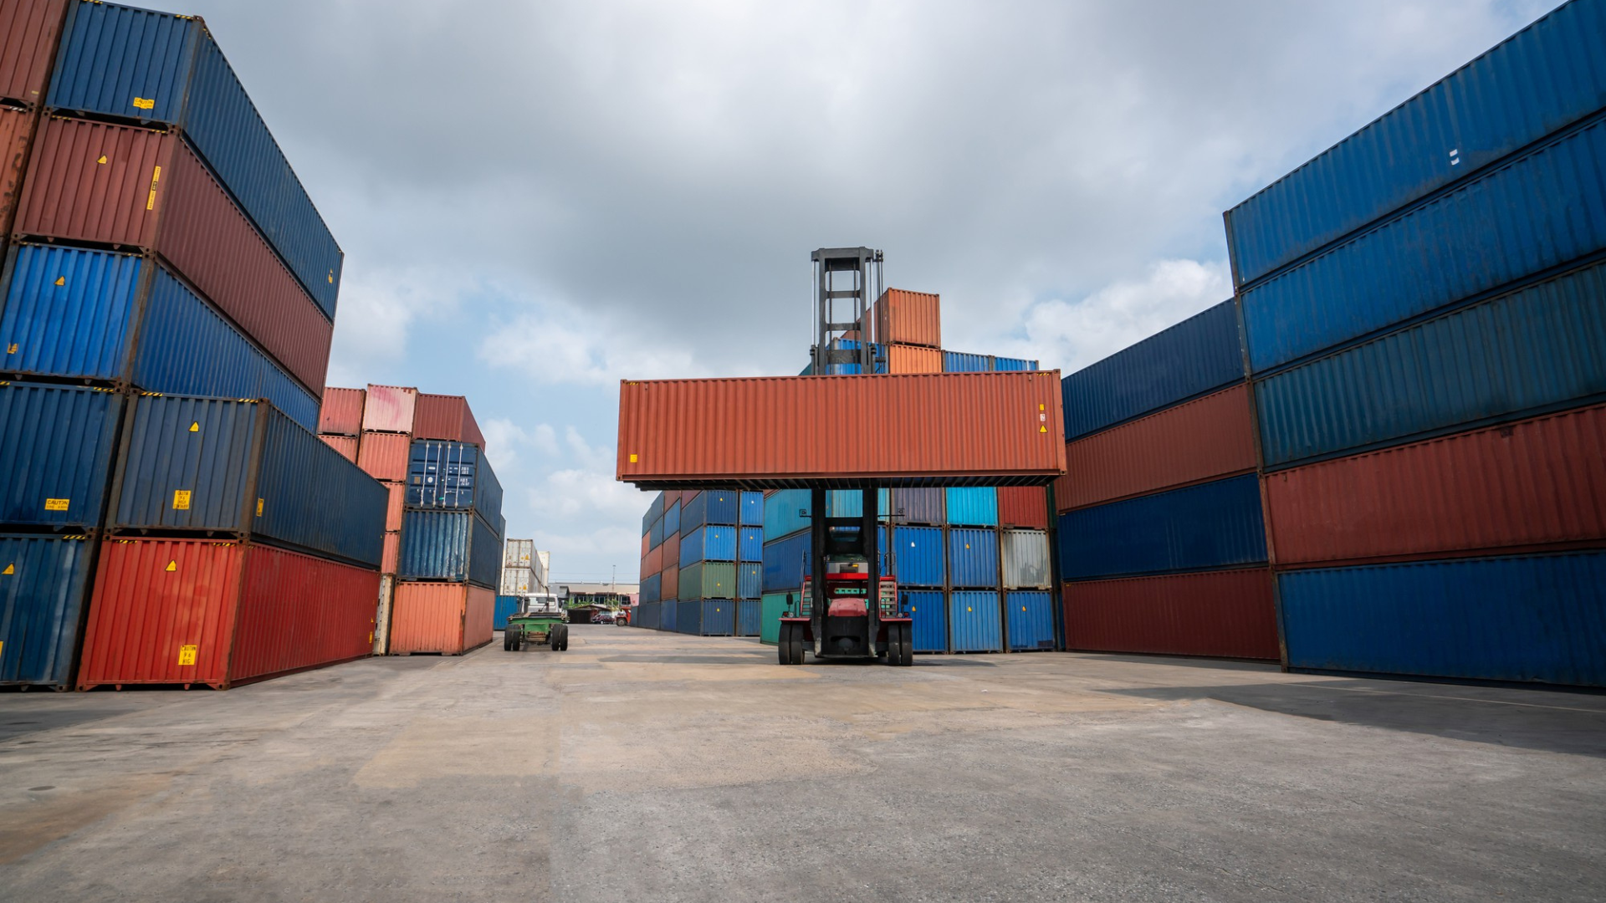

In the global economy, businesses across industries are constantly seeking ways to optimize their logistics operations, reduce costs, improve delivery times and provide better services to customers. At the heart of this process are inland container depot widely known as dry port that store, handle and facilitate the movement of containers along the supply chain. One standout player in this field is ICD, Bawal, operated by **Sanjvik Terminals Pvt. Ltd.**, renowned for its reliable services that drive supply chain efficiency.

Let’s explore how Sanjvik Terminals enhances supply chain efficiency through its robust infrastructure, innovative technology and customer-centric solutions.

**Understanding supply chain efficiency**

Supply chain efficiency means ensuring the seamless flow of goods from the point of origin to the end customer with minimal waste, reduced costs and faster delivery times. Every component of the supply chain, from raw material procurement to the delivery of finished products, must be optimized to ensure overall efficiency.

Sanjvik terminals play a pivotal role in this process. Acting as connectors between suppliers, manufacturers and distributors. This terminal ensures that goods move smoothly through the supply chain while minimizing delays and operational inefficiencies. It excels in this regard by offering advanced logistics solutions that meet the growing demands of modern businesses.

**The Role of Sanjvik Terminals in enhancing efficiency**

Sanjvik Terminals has developed a reputation as a trusted partner by offering reliable services that cater to the diverse needs of its customers. Its key areas of expertise contribute significantly to supply chain efficiency. With the help of its infrastructure and its ability to handle container

**State-of-the-Art Infrastructure**

Sanjvik Terminals’ **state-of-the-art infrastructure** that is critical to its operational efficiency. The terminal is equipped with advanced storage facilities for domestic and EXIM cargo and fully equipped to handle containers with integrated management systems that ensure seamless operation. This infrastructure enables the terminal to handle large volumes of containers swiftly and safely, ensure timely delivery of all the cargo.

Efficient cargo handling is at the core of terminal operations. Sanjvik Terminals’ infrastructure allows it to handle both bulk and containerized shipments, enabling quick processing and minimizing delays. This means goods can be moved in and out of the terminal with minimal friction, reducing the likelihood of bottlenecks and ensuring that delivery schedules are met.

**Expert Cargo Handling**

The speed and accuracy with which a terminal handles cargo directly affect supply chain efficiency. Sanjvik Terminals excels at **streamlined cargo handling processes**. Its experienced workforce, in conjunction with modern handling equipment, ensures that cargo is loaded, unloaded and transferred with maximum speed and care.

The terminal’s team is trained to manage diverse types of cargo, including **coils and automotive parts**, ensuring that each type of product is handled according to its specific requirements. This attention to detail, combined with Sanjvik’s operational efficiency, helps businesses meet tight delivery deadlines while keeping costs under control.

**Services we offer at Sanjvik Terminal**

**1.** **Multi-Modal Transportation**

At Sanjvik Terminals, we specialize in comprehensive multi-modal transportation solutions that integrate road, rail and sea transport. This approach provides flexible and cost-effective logistics options tailored to meet our customers' unique needs.

**Key Benefits:**

* **Integrated solutions-** We seamlessly combine different transport modes for efficient operations, reducing delays and enhancing overall efficiency.
* **Cost-effective options-** Our multi-modal services optimize transit routes, minimizing costs while maximizing delivery speed.
* **Seamless connectivity-** We ensure smooth first-mile and last-mile connectivity, making pickups and deliveries hassle-free.
* **Strategic location-** Our advanced infrastructure and strategic locations allow for efficient handling and transfer of containers.

**2.** **Terminal Management enhancing the flow of containers into the hinterlands**

Sanjvik Terminals has established an **Inland Container Depot (ICD)** at Bawal, a strategic location near major industrial corridors, to meet this growing demand. Our ICD serves as a crucial hub for the movement of containers into the **hinterlands** to ensure smooth and efficient operations.

Services within our Terminal Management are **TXR Examination, container repairing and container leasing**.

**Our Terminal Management Offerings:**

1. **TXR Examination**

o Comprehensive safety checks on rail wagons

o Two dedicated railway lines for on-site TXR examination

o Reduction in rake turnaround time

o Certified inspection of brake systems, couplings, axles, frames and load security

2. **Container Repairing**

o In-house repair and maintenance services

o Skilled technicians using the latest equipment

o Quick turnaround times to minimize container downtime

o Maintenance of containers for safe and reliable operations

3. **Container Leasing**

o High-quality containers available for lease

o Flexible leasing options for short- and long-term projects

o Efficient services ensuring secure transportation and storage

o Tailored leasing options to optimize customer supply chain operations

**Custom Clearance- Simplifying national and international trade**

Navigating the complexities of customs regulations can be a hectic task, but **Sanjvik Terminals' customs clearance** services simplify the process. Our expert team ensures that goods move smoothly across borders by managing all customs documentation and regulatory compliance. We offer complete support for both imports and exports, handling everything from tariff classifications to duty calculations, ensuring that shipments are cleared quickly and efficiently.

Our **Risk Management System (RMS)** further enhances the speed and efficiency of customs clearance, allowing for faster processing and reducing the chances of delays. We also offer **Assistance Economic office (AEO)** office facilities that function as mini customs offices to streamline customs processes even further.

**Warehousing- Secure, Scalable and Strategically Located**

At Sanjvik Terminals, we offer **state-of-the-art warehousing services** designed to cater to diverse storage needs. With 31,000 sq. ft. of optimized storage space, we can accommodate both **bonded** and **domestic warehousing** requirements. Our warehousing solutions are tailored to meet the demands of international and domestic markets, providing secure and scalable storage for businesses of all sizes.

**Our Offerings:**

* Scalable storage solutions for businesses of all sizes
* 8,000 sq. ft. bonded warehouse and 23,000 sq. ft. domestic warehouse
* Customized storage options to meet unique business needs

**Leveraging advanced technology at ICD Bawal**

ICD Bawal is equipped with cutting-edge technology that enhances operational efficiency and customer satisfaction:

* **Risk Management System (RMS):** Streamlines customs clearance, functioning as a green channel for quicker processing through our **Assistance Economic office** (AEO) office.
* **Freight Operating Information System (FOIS):** Customers can track shipments in real time, providing transparency and control over their supply chains.
* **Electrification of the yard -** Electrification of the yard prevents the reversal of engines which is time-consuming. By electric Engine, you do not have the requirement of requisition of the Diesel power or reverse the engine through an escape line because by the electrification, the electric engine can move either way.
* **CCTV Coverage:** Ensures the safety and security of all cargo.

These advancements enable timely and efficient services, keeping customers informed and ensuring seamless operations.

Sanjvik Terminals Pvt. Ltd. at ICD Bawal significantly enhances supply chain efficiency through its advanced infrastructure, expert cargo handling and advance technology. With customized solutions like multi-modal transportation, terminal management, customs clearance and warehousing, we address diverse customer needs, streamlining container movement into the hinterlands.

Our commitment to efficiency and reliability makes us the preferred choice for businesses seeking smooth and effective logistics solutions.